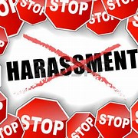
Title IX Training for Employees
LIBI employees took the following online training: Anti-Sexual Harassment Training sponsored by the NYC Commission on Human Rights *, from July 14 - August 14, 2020. https://www1.nyc.gov/site/cchr/law/sexual-harassment-training.page

* The Commission developed this online training to satisfy both the New York State and New York City anti-sexual harassment training requirements. For additional information regarding this mandatory training for current and new employees, please contact: Ms. Catherine Law, Director of Operations and Institutional Effectiveness (claw@libi.edu). Each employee will receive a Certificate upon successful completion of training.

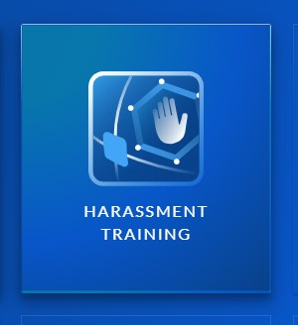
LIBI employees participated in the mandatory online course, Harassment Training, sponsored by HRdirect smart apps * from July 15 – August 14, 2020. The training included up to 6 Modules related to Sexual Harassment Prevention and Response, an annual compliance requirement under Title IX.
* A brief description of each Module follows:
- Understanding Harassment
Introduces the legal definition of harassment and the primary types of problematic behavior.

- Examples of Harassment
Provides real-world examples of prohibited harassment based on legally protected characteristics.

- Special Considerations for Sexual Harassment
Covers specific concerns with sexual harassment, including hostile environment vs. “quid pro quo.”

- Your Responsibility & Reporting
Highlights the role employees play in avoiding illegal behavior and reporting incidents promptly.

- Diversity & Inclusion
Discusses the importance of diversity and inclusion for a respectful, harassment-free workplace.

- Additional Manager Obligations (for managers only)
Educates managers about their specific duties regarding harassment prevention and response.
The Module trainings were voice-activated and ran anywhere from 11-minutes to 21-minutes in length, totaling 105 minutes. Each addressed the types of issues employees may experience or be witness to while in a workplace setting. As each Module was a stand-alone, the training could be taken out of sequence. There was a Quiz at the end of each Module to review for understanding. This course was an invaluable reference for LIBI employees.
For additional information regarding this mandatory training for current and new employees, please contact Professor Julia Scalia, Institutional Title IX Coordinator (jscalia@libi.edu) with questions and/or to reset your password to gain access to the Long Island Business Institute’s Harassment Training account portal sponsored by HRdirect. Each employee will receive a Certificate upon successful completion of training.

